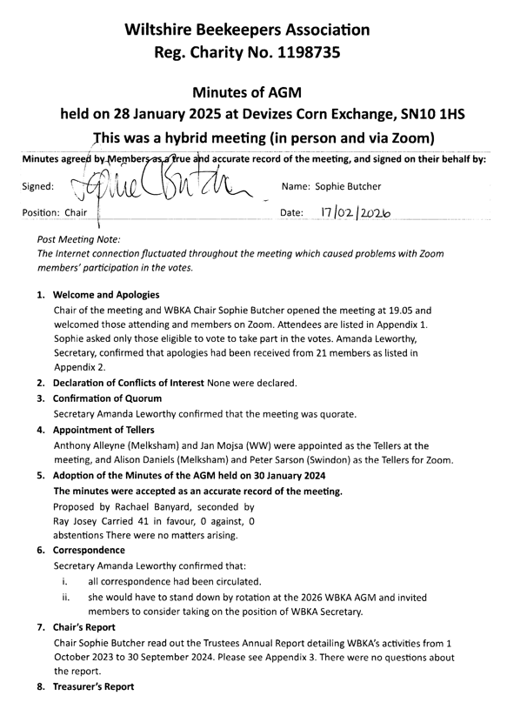

Treasurer Gloria Pilz:
  - offered a massive thank you to her predecessor Ceri Gosling, who had prepared the accounts, which had been necessitated by the significant delay in being able to complete the financial handover because of issues with the bank making the necessary changes.
  - confirmed that she had circulated the financial papers before the meeting.
  - highlighted that a significant expenditure for the branches was their apiaries, which she felt was to be expected as the apiaries were the hub of the members’ beekeeping activities and a focal point for education, one of our Charity objects.
  - announced that to encourage members to improve their knowledge and beekeeping skills, WBKA was trialling a scheme to refund BBKA exam fees for successful candidates and said that the scheme would be reviewed later in the year.
  - reported that she had received queries about the County cash balance and wanted to reassure members that it looked larger than at Branch level because it was the aggregation of the four branches’ and County’s balances.
  - highlighted the need for the Branches to keep a buffer for apiary-related projects, e.g. further development of club facilities and acquisition of a shipping container for storage. vii. reported that, although County did not have its own apiary, County reserves had been set aside to sponsor educational activities, like the exam fee refund scheme mentioned above and a Honey Bee Health Day, and to prepare for the incursion of the Asian Hornet.
Ray Josey asked about Gift Aid and Gloria Pilz confirmed that Gift Aid was passed back to the Branches. There were no other questions.
Acceptance of Treasurer’s Report and approval of the Accounts Proposed by Jeremy Tyler, seconded by Tony Awdry
Carried 51 in favour, 0 against, 0 abstentions
- Election of the Chair
President Chris Rawlings took over as Chair to conduct the election and asked if there were any other nominations for the post. There were none.
Appointment of Sophie Butcher as WBKA Chair
Proposed by Robert Carpenter Turner, seconded by David Raines
Carried 47 in favour, 0 against, 1 abstention
The members congratulated Sophie Butcher on her appointment. Sophie Butcher took over as Chair of the meeting.
- Any Other Business
There was no other business.

Sophie thanked members for attending and closed the meeting at 19.30.

Appendices

- Appendix 1 – AGM Attendees
- Appendix 2 – AGM Apologies
- Appendix 3 – Trustees Annual Report
- Appendix 4 – Treasurer’s Report

APPENDIX 1

AGM 2025 ATTENDEES
Registered Members in Attendance: |  |  | Registered Members in Attendance:
Anthony | Alleyne |  | Pete | Sarson
Stephen | Auty |  | Peter | Stanley
Tony | Awdry |  | Tania | Stevenson
Rachael | Banyard |  | Jeremy | Tyler
Ed | Behan |  | Amanda | Vivian-Crowder
David | Brown |  | Sarah | Watts
Tim | Bullock |  | Peter | West
Sophie | Butcher
Robert | Carpenter Turner |  | Other Attendees:
Michael | Carter |  | E | New
Lucie | Castleman
Dick | Church |  | Registered Member Zoom:
Alison | Daniels
Steve | Double |  | Mark | Fife
Chris | Exton |  | Liz | Gwinnell
Lisa | Gates |  | Clive | Harris
Ceri | Gosling |  | Jane | Hart
Alan | Hepper |  | Robert | Hart
Tony | Hill |  | Kevin | Holt
Kathy | Hobson |  | Alan | Iles
Charles | Irvine |  | Donna | Jones
Elaine | Irvine |  | Marcel | Marsh
Ray | Josey |  | Sian | Morgan
Amanda | Leworthy |  | Nicola | Perrott
Sonia | Meadows |  | Patrick | Philby
Jan | Mojsa |  | Mark | Preece
John | New |  | Sian | Roberts
David | Newell |  | Anja | Shortland
Matt | O’Dell |  | Alexandra | Sparke
Jeremy | Percy |  | David | Talbutt
Larry | Phipps
Gloria | Pilz |  | Local Member Zoom:
David | Raines |  | Richard | Oliver
Chris | Rawlings |  | Clea | Sambrook
APPENDIX 2

APOLOGIES

Avril | Earl
Russell | Evans
Andrew | Farebrother
Terri | Fosker
Shirley | Gale
Richard | Green
Susan | Hutchinson
Craig | Jamieson
Cathy | Lawrence
Elaine | Lewis
Stuart | Lynch
Bob | Lytton
Elaine | Mairis
Peter | May
Tony | Moore
Emma | Morley
Melani | Oliver
Den | Pictor
Diane | Sleigh
Andrea | Waylen
Brian | Wilson

APPENDIX 3

TRUSTEES ANNUAL REPORT 2023-24
The charitable objects of the Wiltshire Beekeepers Association are to advance the education of the public and beekeepers in the craft of beekeeping and promote the importance of bees in the environment. We have done this in several ways this year.
- We engage with and develop the skills of existing beekeeping members in many ways: through courses and exams in Basic Beekeeping and General Husbandry, the BBKA Module study groups and exams, the production of the Honey Bee Times, and in talks both at branch and county level.
  - Last summer, 11 candidates passed the Basic exam, 3 with Distinction, 6 with credit.
  - Around 24% of the total membership has taken the Basic Exam. This continues to be an area we need to work on next year although it should be noted that the influx of new beekeepers to the membership always skews this figure, as they are not eligible to take the exam for two years.
  - 12 candidates took the BBKA Module exams as follows:
    - 3 passed Module 2
    - 1 passed Module 3
    - 1 passed Module 5 with Credit
    - 6 passed Module 6, 2 with Credit and 2 with Distinction
    - 1 passed Module 8 with Credit
  - 1 candidate achieved the General Husbandry Certificate. Congratulations to everybody.
- We also encourage potential beekeepers.
  - 28 members of the public attended taster days.
  - There were at least 4 open apiary days where the public could attend.
  - Meanwhile over 70 people learned how to keep bees in four Introduction to Beekeeping courses across the county. Not all went on to take up beekeeping this year but may come back to it when personal circumstances allow. Nevertheless, they are now better informed about bees, pollinators, beekeeping and the environment.
- At least 7 schools have formally invited members to talk to pupils about bees in the environment. During the summer term, such visits may also include bees in an observation hive.
- There were at least 10 presentations on beekeeping to local groups including residential care homes, nursery schools and a Cub pack.
- On another front, Wiltshire Beekeepers’ interests were represented at the British Beekeepers Association Annual Delegate Meeting and the South West Beekeepers Forum.
- We ensure that relevant information is circulated to members through appropriate channels, including regarding Asian hornet incursions and other National Bee Unit alerts.
- Talking of which, in 2024 there were 24 Asian hornet incursions to the UK and hopefully the National Bee Unit dealt with all nests in good time to prevent the new queens emerging. Meanwhile, last January, 14 members of the Wiltshire Asian Hornet Action Team (which we call AHAT) attended the 2nd South West Beekeepers Forum Asian Hornet Conference to learn best practice and prepare for Asian hornet incursions into the county this year. This will enable the charity to support the National Bee Unit in verification and tracking activities as necessary.
- At the other end of the scale, we have over 80 approved swarm collectors in the county.
They provide a free 24/7 swarm collection service to residents in most of Wiltshire (except in the Salisbury area, where the Salisbury Beekeepers Association provides a similar service).
  - Calls are made to our Branch Swarm Co-ordinators and sometimes direct to our branch beekeepers.
  - The majority of collected swarms were retained by the swarm collector; some were provided to other beekeepers.
  - Along with dealing with swarms, we also dealt with bees in roofs or cavities and a few wasp nests, as well as enquiries which turned out to be mining bees and bumble bees.
- At the beginning of the 2024-25 financial year, we staged the Wiltshire Bee & Honey Day, which is currently our biggest public-facing event of the year. Around 400 people attended the event.
  - Held in the Corn Exchange, Devizes, the 2024 event included fascinating talks aimed at both beekeepers and the general public, which went down tremendously well.
  - There were just under 300 entries in the honey show.
  - £1,155-worth of members’ honey was sold, as were 3 kegs of Wadworth honey beer at nearly £500, and £239-worth of teas and coffees, while 200 biodegradable balloons on biodegradable sticks were given away to children. Income from sponsors and trade stands amounted to £960. Over 60 children enjoyed themselves rolling a beeswax candle while beekeepers explained the role of wax in the hive to them and their family, and dozens of other children made model bees and learned about pollination from Sherill Percy and her team, after which their parents browsed the stalls selling bee-related gifts, wildflower seeds, honey and candles.
  - Before awarding cups on the day, the Mayor, Councillor Ian Hopkins, toured the event and spent a few minutes with WBKA President Chris Rawlings learning about how mead is made. The Mayor and his wife enjoyed the Wadworth honey beer and Hive Mind mead.
  - The show cost just over £3,940 to stage (up £680 compared to last year) but thanks to the various income streams at the show, the net cost was around £980. The show committee was able to return the balance of the £2000 operating budget (just over £1,000) to the Wiltshire Beekeepers Association.
- Other public-facing events included assisting in the Bee Tent at the Bath & West Show last June, where members of the public could find out more about bees and beekeeping. Wiltshire members contributed to over £6,000 worth of honey sales. Several members also successfully competed at the show and Wiltshire walked away with 6 Trophies for individual members, plus we retained the County Shield for the Association with the most points. The Wiltshire Beekeepers’ candle display of “Creatures Great and Small” was considered the outstanding Stand/Demonstration. Another highlight was the Wiltshire President’s 5 year old granddaughter assisting at a couple of the bee handling demonstrations.
- The Field to Food Event, held in conjunction with Somerset BKA in April at the Bath & West Showground, was attended by 1,500 primary school children, who were able to see real bees in the observation hive, get their hands on beekeeping equipment and see honey and wax and other hive-related products.
- The branches were represented in at least 9 local fetes and fairs. At summer fetes this may include an observation hive.
- Looking inwards, one branch completed construction of their honey kitchen in which they demonstrate and facilitate honey extraction.
- Running alongside the regular club apiary sessions between April and September (weather-permitting), kit building sessions and a wax masterclass were held and there was a walk to discover a local drone congregation area.
- We have been able to reinvigorate our County newsletter, the Honey Bee Times, which aims to educate and inspire members, as well as keeping them abreast of what is going on in the other Branches.
- The Trustees met quarterly in various location around the county to drive the operations of the charity forward. We continue to work on a strategy and modus operandi to develop special projects in line with our charitable objects.
- We closed the year on 30 September with 498 members in four Branches, most of whom have gone on to renew their membership.
- I would like to thank the Branch Chairs for their role in developing interest, knowledge and camaraderie at grassroot level.

Sophie Butcher,
Chair of the Wiltshire Beekeepers Association
On behalf of the Wiltshire Beekeepers Association Trustees
November 2024

APPENDIX 4

Wiltshire Beekeepers Association AGM 2025 Financial Reporting
The Accounts have been produced with immense thanks to Ceri Gosling, our previous Treasurer, and whose support has been instrumental during our period of handover in 2024.
The accounts we present are Receipts and Payments accounts, presented with comparative values for the previous year. We continue to maintain a principle of delegation to the branches, where their officers manage their own affairs. This is only limited by the governance obligation of the county as the Charity.
In line with the requirements of the Charity Commission, the aggregated accounts have been reviewed by an Independent Accountant, Lucy Wood (a Chartered Accountant working in public practice). Her review does not constitute an audit, the review is to confirm that the accounts reflect the underlying accounting records supplied to her, including bank statements, but she would not have checked the detail of each transaction, relying on the treasurers of the respective branches to accurately record transactions.
The comments presented are an amalgamation from both Ceri and myself.
For values that are broadly similar, this is taken as business as usual. For some of the other items, you may find the following comments of interest:
A1.1 Donations received. In the prior year Kennet received a single donation of £750, there was nothing comparable in the new year.
A1.2 Membership receipts. This is probably the hardest line in the accounts to explain simply. We received almost £3,000 less in the new year than in the comparative year, but much of this is to do with timing. Every year there are members who pay early, so the receipts in any year are a mix of payments for that year and early payments for the next year. If the number of people paying early is similar from year to year, the receipts will roughly reflect membership numbers. In the new year the value of early payments in September 2024 was slightly higher than it had been in September 2023, but only by about
£300. However, the prior year value was more significantly inflated because we collected a much greater value of early payments in September 2023 than we had in September 2022, the difference was approximately £2,300. So £2,000 of the movement can be attributed to timing, leaving an underlying fall of about £1,000 that was driven by membership headcount. At line A3.2 there is evidence that membership of the BBKA falling a little.
A1.5 County Honey Show Receipts were down from the prior year by about £500. I don't have a detailed understanding of what drove this, but it is consistent with my understanding that the show held in October 2023 required a modest central subsidy where the show held in October 2022 was self funding. The subsidy required for 2023 was consistent with the results of earlier years. The results of the 2022 show may have been the exception, being the first after the period of "lock down".
A1.7 Sundry Non-Core Receipts were up by almost £470. As interest rates have risen in the markets, some branches have put reserves in interest baring accounts, and this earned £150. West Wilts received compensation from Lloyds bank of £285, County received £50. The compensation was a result of administrative inefficiencies rather than fraudulent activity.
A3.1 Donation Payments rose, driven by the Trustees approving payments from the central accounts to the National Honey Show, the BBKA convention and the Bath and West show. This includes a 20 year endowment for 2 classes at the National Honey Show, previously, we supported 2 classes on a year by year basis.
A3.3 Education Payments rose following the decision to subsidise members examination fees.
